**Result**

**Study of function in the integral**



The overall equation



The overall variation of the specific heat capacity with temperature is shown in the figure above. The expression of specific heat capacity is a general one that tends to explain the characteristic curve of specific heat capacity at low temperatures as well as at high temperatures. The expression which consists of phonon and electronic contribution seems to be consistent with Dulong-petit law. Dulong petit law says that specific heat capacity per molar mass is a constant value, equal to 3R. This result can be observed in the figure above at high temperatures, where the curve tends to be flat and tends to assume a constant value, as predicted by Dulong-petit law.

One more thing that I found and felt like worth mentioning is that the function in the integral is similar to Maxwell-Boltman distribution.

**Maxwell- boltman distribution**

 f(v) = \sqrt{\frac{2}{\pi}\left(\frac{m}{kT}\right)^3}\, v^2 \exp \left(\frac{-mv^2}{2kT}\right) 

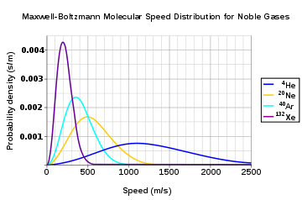

The curve of the function f, in the integral is also the same and has the same form, which is evident from the figure below.



This curve is similar to maxwelll boltmann distribution.

**Function of e^-x * x^2**

